1. Huffman coding –en-/de-coding tree

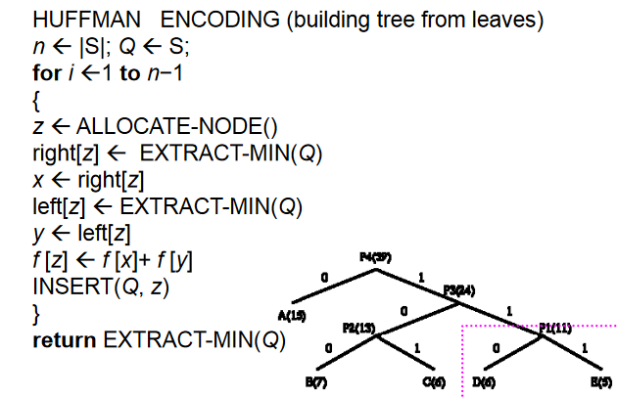

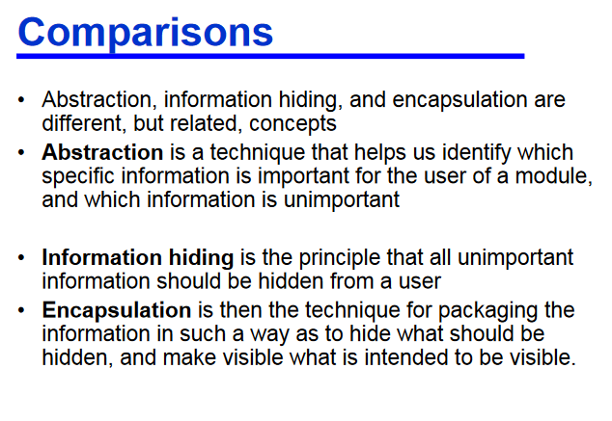

2.Infix expressions

•Binary operators appear between operands

•a + b

Prefix expressions

•Binary operators appear before operands

•+ a b

Postfix expressions

•Binary operators appear after operands

•a b +